Name: __________________________ Date: _____________

1. | Which of the ordered pairs  (3, 1), (0, –4), (–4, 0), (–3, –7)  are solutions for the equation ?

2. | Give the coordinates of the point graphed below.

3. | Draw a graph showing the point with coordinates (–4, 3).

4. | Graph

5. | Graph .

6. | Graph .

7. | Which graph below is the graph of ?
 | A) | 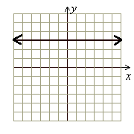
 | B) | 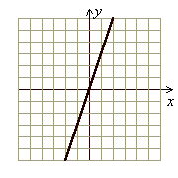
 | C) | 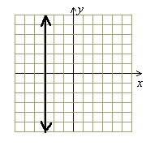
 | D) | 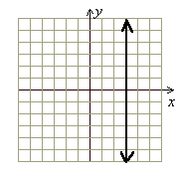

8. | Graph using the intercept method: , show your work calculating the intercepts (both y-intercept and x-intercept)

9. | Find the slope of the line passing through the points (3, –2) and  (–8, 6).

10. | What is the slope of the below graphed line?  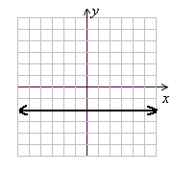

11. | What is the slope and y-intercept of

12. | What is the y-intercept of

13. | (a) Write the equation of the line with slope –2 and y-intercept (0, 0). (b) Then draw the graph of that line.

14. | Match the following graph with one of the equations.  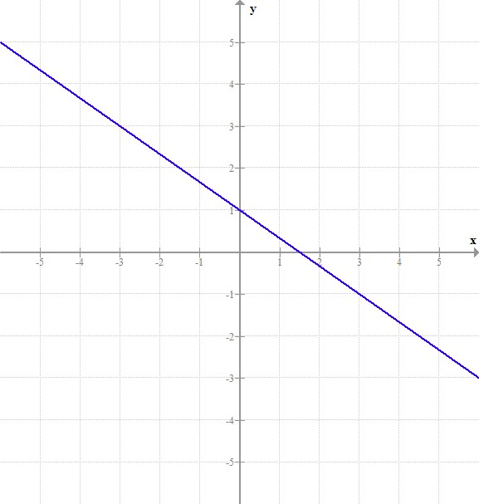  Note: This line intersects the ‘y’ axis at (0, 1) and intersects the ‘x’ axis at
 | A)
 | B)
 | C)
 | D) | y = 2x – 1

15. | Determine which two equations represent parallel lines.
  (a) | (b) | (c) | (d)
 | A) | (a) and (d)
 | B) | (a) and (b)
 | C) | (c) and (d)
 | D) | (b) and (c)

16. | Determine which two equations represent perpendicular lines.
  (a) | (b) | (c) | (d)
 | A) | (a) and (d)
 | B) | (a) and (b)
 | C) | (c) and (d)
 | D) | (b) and (c)

17. | Are the following lines parallel, perpendicular, or neither (show your work—do not graph the lines as proof, use math to prove)?  L₁ with equation  L₂ with equation

18. | Write the equation of the line that passes through point (0, 2) with a slope of 9.

19. | Write the equation of the line passing through (–2, –10) and (–2, –5).

20. | Write the equation of the line which has y-intercept (0, 5) and is perpendicular to the line with equation .

